NYU, Tandon School of Engineering  
Extended Bridge to CS – Summer 2022  
Homework #5

Rozalin Mohanty  
[rm6102@nyu.edu](mailto:rm6102@nyu.edu)

Note: The greyed-out portions in the solutions are rough workings or my own additional notes. You need not mark them.

**Question 3**

**A. Exercise 4.1.3**

Which of the following are functions from **R** to **R?** If f is a function, give its range.

**b. $f\left(x\right)=1/ (x^{2}-4)$**

f is not a well-defined function from **R** to **R.** When x = 2 or x = -2, then f(x) = 1/ 0, which is undefined.

**c. $f\left(x\right)=\sqrt{x^{2}}$**

f is a well-defined function from **R** to **R.** Range = [0,∞).

**B. Exercise 4.1.5**

Express the range of each function using roster notation.

**b.**

Let A = {2, 3, 4, 5}.  
f: A → **Z** such that f(x) = x2.

Range = {4, 9, 15, 25}

**d.**

f: {0,1}5 → **Z**. For x ∈ {0,1}5, f(x) is the number of 1's that occur in x. For example f(01101) = 3, because there are three 1's in the string "01101".

Range = {0, 1, 2, 3, 4, 5}

**h.**

Let A = {1, 2, 3}.  
f: A × A → **Z**×**Z**, where f (x, y) = (y, x).

A × A = {(1, 1), (1, 2), (1, 3), (2, 1), (2, 2), (2, 3), (3, 1), (3, 2), (3, 3)}

Range = {(1, 1), (2, 1), (3,1), (1, 2), (2, 2), (3, 2), (1, 3), (2, 3), (3, 3)}

**i.**

Let A = {1, 2, 3}.  
f: A × A → **Z**×**Z**, where f(x, y) = (x, y+1).

A × A = {(1, 1), (1, 2), (1, 3), (2, 1), (2, 2), (2, 3), (3, 1), (3, 2), (3, 3)}

Range = {(1, 2), (1, 3), (1, 4), (2, 2), (2, 3), (2, 4), (3, 2), (3, 3), (3, 4)}

**l.**

Let A = {1, 2, 3}.  
f: P(A) → P(A). For X ⊆ A, f(X) = X - {1}.

P(A) = {Ø, {1}, {2}, {3}, {1,2}, {1,3}, {2,3}, {1,2,3}}

Range = {Ø, {2}, {3}, {2,3}}

**Question 4**

**A. Exercise 4.2.2**

For each of the functions below, indicate whether the function is onto, one-to-one, neither or both. If the function is not onto or not one-to-one, give an example showing why.

* A function f: X → Y is ***one-to-one*** or ***injective*** if x1 ≠ x2 implies that f(x1) ≠ f(x2). That is, f maps different elements in X to different elements in Y.
* A function f: X → Y is ***onto*** or ***surjective*** if the range of f is equal to the target Y. That is, for every y ∈ Y, there is an x ∈ X such that f(x) = y.
* A function is ***bijective*** if it is both one-to-one and onto. A bijective function is called a ***bijection***. A bijection is also called a ***one-to-one correspondence***.

**c.** h: **Z** → **Z**. h(x) = x3

* The function is **not onto**. For example, there is no integer x such that h(x)= 2.
* The function is **one-to-one**.

**g.** f: Z × Z → **Z** × **Z**, f (x, y) = (x+1, 2y)

* The function is **not onto**. For example, there is no pair (x, y) such that f(x, y) = (0,1)
* The function is **one-to-one**.

**k**. f: **Z+ × Z+ → Z+** +, f(x, y) = 2x + y.

* The function is **not onto**. For example, there is no pair (x, y) such that f(x, y) = 1.
* The function is **not one-to-one**. For example, f(2, 1) = f(1, 3) = 5.

**B. Exercise 4.2.4**

***Part I***

For each of the functions below, indicate whether the function is onto, one-to-one, neither or both. If the function is not onto or not one-to-one, give an example showing why.

**b.**

f: {0, 1}3→{0, 1}3. The output of f is obtained by taking the input string and replacing the first bit by 1, regardless of whether the first bit is a 0 or 1. For example, f(001) = 101 and f(110) = 110.

* The function is **not onto**. For example, there is no string, s, such that f(s) = 000.
* The function is not **one-to-one**. For example, f(101) = f(001) = 001.

**c.**

f: {0, 1}3→{0, 1}3. The output of f is obtained by taking the input string and reversing the bits. For example f(011) = 110.

* The function is **onto** and **one-to-one**.

**d.**

f: {0, 1}3→{0, 1}4. The output of f is obtained by taking the input string and adding an extra copy of the first bit to the end of the string. For example, f(100) = 1001.

* The function is **not onto**. For example, there is no string s, such that f(s) = 0001.
* The function is **one-to-one**.

**g.**

Let A be defined to be the set {1, 2, 3, 4, 5, 6, 7, 8} and let B = {1}. f: P(A) → P(A). For X ⊆ A, f(X) = X - B. Recall that for a finite set A, P(A) denotes the power set of A which is the set of all subsets of A.

* The function is **not onto**. For example, there is no value of X, such that f(X) = {1}.
* The function is not **one-to-one**. For example, f({1, 2, 3}) = f({2, 3}) = {2, 3}.

***Part II***

Give an example of a function from the set of integers to the set of positive integers that is:

**a.** one-to-one, but not onto.

$$f(x)=\left\{\begin{aligned}2x, if x>0 \\ -2x+3 &if x≤0\end{aligned}\right.$$

* This function is not onto. For example, there is no value of x such that f(x) = 1.

**b.** onto, but not one-to-one.

$$f\left(x\right)=\left|x\right|+1$$

* This function is not one-to-one. For example f(-1) = f(1) = 2.

**c.** one-to-one and onto.

$$f(x)=\left\{\begin{aligned}2x, if x>0 \\ -2x+1 &if x≤0\end{aligned}\right.$$

**d.** neither one-to-one nor onto.

$f\left(x\right)=1$

* This function is not one-to-one. For example, f(-1) = f(2) = 1.
* This function is not onto. For example, there is no x such that f(x) = 2.

**Question 5**

**A. Exercise 4.3.2**

For each of the following functions, indicate whether the function has a well-defined inverse. If the inverse is well-defined, give the input/output relationship of f−1.

**c.**

**d.**

The above function is not one-to-one and does not have a well-defined inverse.

* Note: |X| in the context of sets, refers to the cardinality or number of elements in the set and not absolute value. In the above, there will be multiple sets with the same number of elements, which is why the function is not one-to-one.

**g.**

**i.**

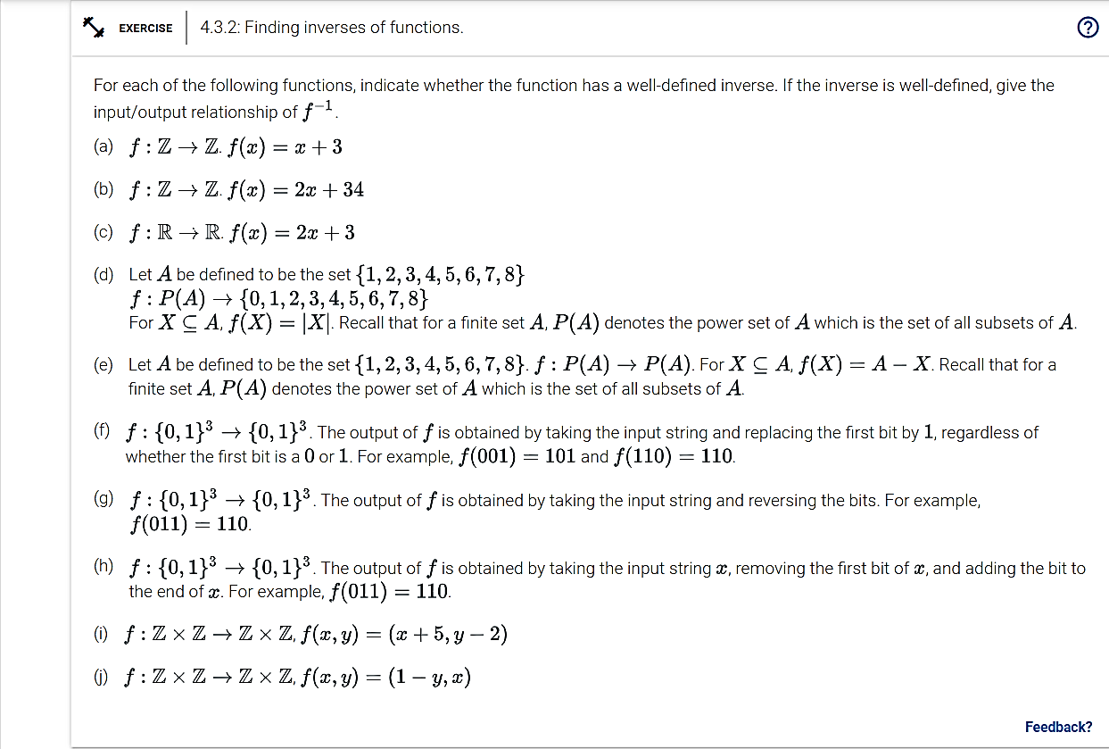

**B. Exercise 4.4.8**

The domain and target set of functions f, g, and h are **Z**. The functions are defined as:

* f(x) = 2x + 3
* g(x) = 5x + 7
* h(x) = x2 + 1

Give an explicit formula for each function given below.

**c.** f ο h

f ο h   
= 2(x2 + 1) + 3   
= 2x2 + 5

**d.** h ο f

h ο f  
= (2x + 3)2 + 1  
= 4x2 + 12x + 10

**C. Exercise 4.4.2**

Consider three functions f, g, and h, whose domain and target are **Z**. Let

**b.** Evaluate (f ο h)(52)

(f ο h)(52)

= ${\left\lceil \frac{52}{5} \right\rceil }^{2}$

= ${11}^{2}$

= 121

Note: The partial bracket used above denotes ceiling. If flipped, it would denote floor.

**c.** Evaluate (g ο h ο f)(4)

(g ο h ο f)(4)

= $2^{\left\lceil \frac{4^{2}}{5} \right\rceil }$

= 16

**d.** Give a mathematical expression for h ο f.

h ο f = $\left\lceil \frac{x^{2}}{5} \right\rceil$

**D. Exercise 4.4.6**

Define the following functions f, g, and h:

* f: {0, 1}3→{0, 1}3. The output of f is obtained by taking the input string and replacing the first bit by 1, regardless of whether the first bit is a 0 or 1. For example, f(001) = 101 and f(110) = 110.
* g: {0, 1}3→{0, 1}3. The output of g is obtained by taking the input string and reversing the bits. For example, g(011) = 110.
* h: {0, 1}3→{0, 1}3. The output of h is obtained by taking the input string x, and replacing the last bit with a copy of the first bit. For example, h(011) = 010.

**c.** What is (h ο f)(010)?

(h ο f)(010) = h(110) = 111

**d.** What is the range of h ο f?

Range = {101, 111}

|  |  |
| --- | --- |
| Possible inputs for f  {000, 100, 010, 101, 001, 111, 110, 011)  Possible outputs for f (first bit is replaced by 1)  {100, 110, 101, 111} | Possible outputs for h (last bit is replaced with a copy of the first bit)  {101, 111} |

**e.** What is the range of g ο f?

Range = {001, 011, 101, 111}

|  |  |
| --- | --- |
| Possible inputs for f  {000, 100, 010, 101, 001, 111, 110, 011)  Possible outputs for f (first bit is replaced by 1)  {100, 110, 101, 111} | Possible outputs for g (bits are reverse)  {001, 011, 101, 111} |

**E. Exercise 4.4.4 (optional extra credit problem)**

Let f: X → Y and g: Y → Z be two functions.

**c.** Is it possible that f is not one-to-one and g ο f is one-to-one? Justify your answer. If the answer is "yes", give a specific example for f and g.

No. If f is not one-to-one, then g o f is not one-to-one either. If f is not one-to-one, then there is at least one case where f (x1) = f (x2 ) = y1. Thus, there would be at least one case where g o f (x1) = g o f (x2) = z1.

**d.** Is it possible that g is not one-to-one and g ο f is one-to-one? Justify your answer. If the answer is "yes", give a specific example for f and g.

Yes. For example, f, g: **R**→**R**, f(x)=ex and g(x)=x2.